Edge Linking (Local Processing, Global Processing
Code:
import cv2
import numpy as np
image = cv2.imread('fel.jpg')
gray = cv2.cvtColor(image, cv2.COLOR_BGR2GRAY)
edges = cv2.Canny(gray, 50, 150, apertureSize=3)
kernel = np.ones((3, 3), np.uint8)
dilated_edges = cv2.dilate(edges, kernel, iterations=1)
contours, _ = cv2.findContours(dilated_edges, cv2.RETR_EXTERNAL, cv2.CHAIN_APPROX_SIMPLE)
image_with_contours = image.copy()
cv2.drawContours(image_with_contours, contours, -1, (0, 255, 0), 2)
cv2.imshow('Edge Linking Result', image_with_contours)
cv2.waitKey(0)
cv2.destroyAllWindows()
Code Explanation
Here is an explanation of the code used for Edge Linking (Local and Global Processing):
- Importing Required Libraries:
import cv2
import numpy as np
  - cv2: This is the OpenCV library, used for image processing tasks.
  - numpy: This is used for numerical operations, especially for creating and manipulating arrays (e.g., for defining the kernel in morphological operations).
- Loading the Image:
image = cv2.imread('fel.jpg')
  - This line loads the input image (fel.jpg) from the file system and stores it in the variable image.
- Converting the Image to Grayscale:
gray = cv2.cvtColor(image, cv2.COLOR_BGR2GRAY)
  - The cv2.cvtColor() function is used to convert the image from its original BGR (blue, green, red) color space to grayscale. This simplifies edge detection as it works on a single intensity channel instead of three color channels.
- Edge Detection using Canny:
edges = cv2.Canny(gray, 50, 150, apertureSize=3)
  - Canny edge detection is applied to the grayscale image (gray). The Canny edge detector is a popular edge-detection algorithm that identifies areas of rapid intensity change in an image.
  - The threshold values 50 and 150 are the lower and upper thresholds for edge detection. The apertureSize=3 parameter defines the size of the Sobel kernel used for gradient calculation.
- Local Edge Linking with Dilation:
kernel = np.ones((3, 3), np.uint8)
dilated_edges = cv2.dilate(edges, kernel, iterations=1)
  - Dilation is a morphological operation that increases the size of white regions in a binary image. It is used here to connect edge segments that are close to each other.
  - The kernel is a 3x3 matrix of ones, which defines the shape of the dilation. The dilation operation is applied once (iterations=1).
- Global Edge Linking with Contour Detection:
contours, _ = cv2.findContours(dilated_edges, cv2.RETR_EXTERNAL, cv2.CHAIN_APPROX_SIMPLE)
  - Contour detection is applied to the dilated edge image (dilated_edges). Contours are the boundaries of the objects or regions in the image that have a connected set of edge pixels.
  - cv2.RETR_EXTERNAL retrieves only the outermost contours.
  - cv2.CHAIN_APPROX_SIMPLE simplifies the contour points by approximating straight lines.
- Drawing the Contours:
image_with_contours = image.copy()
cv2.drawContours(image_with_contours, contours, -1, (0, 255, 0), 2)
  - A copy of the original image is created (image_with_contours) to draw the contours on it.
  - The cv2.drawContours() function is used to draw the detected contours on the image in green color (0, 255, 0) with a thickness of 2 pixels.
- Displaying the Result:
python
cv2.imshow('Edge Linking Result', image_with_contours)
cv2.waitKey(0)
cv2.destroyAllWindows()
  - cv2.imshow() displays the image with the drawn contours (i.e., the edge-linked result).
  - cv2.waitKey(0) waits for a key press before closing the displayed image.
  - cv2.destroyAllWindows() closes all OpenCV windows after the key press.

Summary
This code applies edge linking to an image using both local processing (dilation) and global processing (contour detection):
- Local Processing: Dilation is used to connect nearby edges that were detected in the Canny edge detection step.
- Global Processing: Contour detection is used to link edges across the entire image and form continuous boundaries.
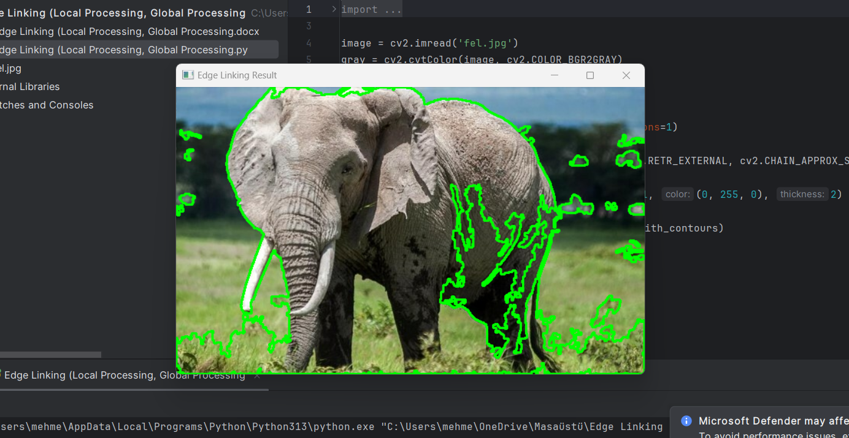
Output:

Report

1. Introduction
In computer vision, edge detection is a crucial technique for identifying boundaries within an image. However, detected edges are often fragmented due to noise or gaps between edge segments. Edge linking is the process of connecting these discontinuous edges to form continuous boundaries. This report demonstrates the application of local processing and global processing techniques for edge linking using the OpenCV library. The image used for this experiment is fel.jpg.

2. Objective
The primary goal of this project is to apply edge linking using local and global processing methods:
- Local Processing: Uses morphological operations like dilation to connect nearby edges.
- Global Processing: Uses contour detection to link edges over the entire image and form closed or meaningful boundaries.

3. Methodology
The following steps were carried out for edge detection and linking:
- Image Preprocessing:
  - Convert the input image to grayscale for simplified edge detection.
- Edge Detection:
  - Apply the Canny edge detector to identify edges in the grayscale image.
- Edge Linking:
  - Local Processing: Use dilation to connect nearby edges.
  - Global Processing: Apply contour detection to detect continuous edges and boundaries.
- Visualization:
  - The linked edges (from both local and global processing) are drawn on the original image for visualization.

4. Algorithm
The steps followed in the code implementation can be summarized as:
- Image Loading: The input image fel.jpg is loaded.
- Grayscale Conversion: The image is converted to grayscale to simplify the edge detection process.
- Edge Detection: The Canny edge detector is applied to detect edges in the grayscale image.
- Local Processing (Dilation): The detected edges are dilated to connect nearby edge segments.
- Global Processing (Contour Detection): Contour detection is used to detect the boundaries formed by the linked edges.
- Drawing the Edges: The contours are drawn on a copy of the original image to visualize the result.
- Displaying the Result: The final image, with linked edges, is displayed.

5. Code Implementation
import cv2
import numpy as np

image = cv2.imread('fel.jpg')
gray = cv2.cvtColor(image, cv2.COLOR_BGR2GRAY)
edges = cv2.Canny(gray, 50, 150, apertureSize=3)

kernel = np.ones((3, 3), np.uint8)
dilated_edges = cv2.dilate(edges, kernel, iterations=1)

contours, _ = cv2.findContours(dilated_edges, cv2.RETR_EXTERNAL, cv2.CHAIN_APPROX_SIMPLE)
image_with_contours = image.copy()
cv2.drawContours(image_with_contours, contours, -1, (0, 255, 0), 2)
cv2.imshow('Edge Linking Result', image_with_contours)
cv2.waitKey(0)
cv2.destroyAllWindows()
- Loading the Image: The image fel.jpg is loaded into the variable image.
- Grayscale Conversion: The image is converted to grayscale using cv2.cvtColor().
- Edge Detection: The Canny edge detector is applied to the grayscale image.
- Local Processing: Dilation is performed on the detected edges to connect nearby edge segments.
- Global Processing: Contours of the connected edges are found using cv2.findContours().
- Drawing and Displaying: The contours are drawn on the original image in green and displayed using cv2.imshow().
6. Results and Observations
- Local Processing: The dilation operation helped connect fragmented edges that were initially detected by the Canny edge detector. The edges became continuous, making the edge structure more coherent.
- Global Processing: Using contour detection, the system was able to detect larger structures formed by the connected edges. This helped in identifying meaningful boundaries and regions in the image.
The final output image displayed edges that were not only connected locally but also globally, revealing continuous object boundaries.

